EVENING PRAYER Canticle of Mary
Tone 11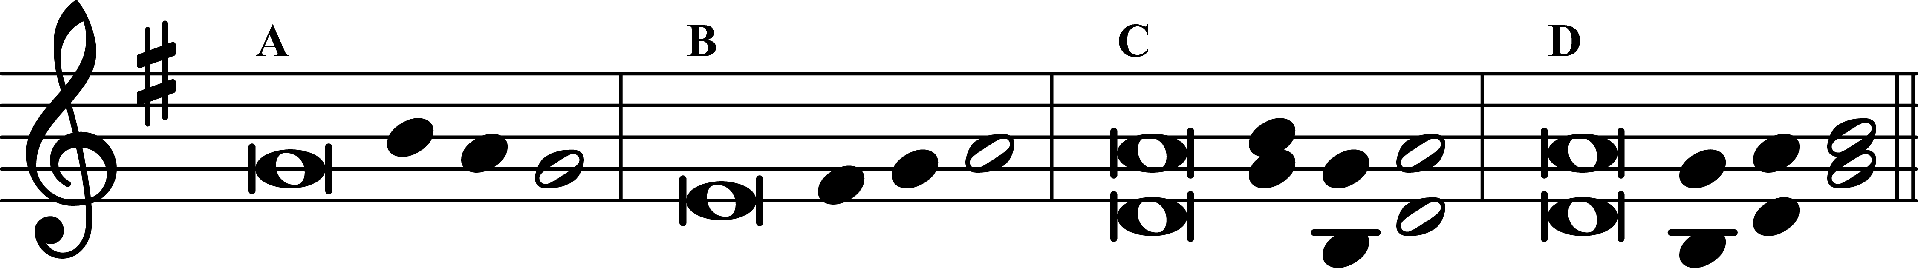

Gospel Canticle Luke 1: 46–55

46 My soul proclaims the greatness of the Lord, †
47 and my spirit rejoices in God my Savior,
48 for he has looked upon his handmaid in her lowliness;
for behold, from this day forward,
all generations will call me blessèd.
49 For the Almighty has done great things for me,
and holy is his name.
50 His mercy is from age to age
for those who fear him.
51 He has made known the strength of his arm,
and has scattered the proud in their con‧⁠ceit of heart.
52 He has cast down the mighty from their thrones
and has exalted those who are lowly. ——
53 He has filled the hungry with good things,
and has sent the rich a‧⁠⁠way empty.
54 He has helped his ser‧⁠vant Israel,
mindful of his mercy,
55 even as he promised to our fathers,
to Abraham and his descend‧⁠ants forever. ◆
Glory to the Father, and to the Son,
and to the Ho‧⁠ly Spirit:
as it was in the begin‧⁠ning, is now,
and will be for ev‧⁠er. Amen.

MORNING PRAYER Canticle of Zechariah
Tone 11

Gospel Canticle Luke 1: 68–79

68 Blessed be the Lord God of Israel:
for he has visited his people and redeemed them;
69 he has raised up for us a horn of salvation
in the House of Da‧⁠vid his servant, ——
70 as he spoke through the mouth of his holy ones,
his prophets from a‧⁠ges past:
71 To grant salvation from our foes,
and from the hand of all who hate us,
72 showing mercy to our fathers, †
remembering his ho‧⁠ly covenant;
73 the oath he swore to Abra‧ham our father;
74 To grant that freed from the hand of our foes,
75 we may serve him with‧⁠out fear
in holi‧⁠ness and righteousness
all the days of our life.
76 And you, little child, will be called
the Prophet of the Most High,
for you will go be‧⁠fore the Lord
to make read‧⁠y his ways: ——
77 to grant knowledge of salvation to his people
by the forgiveness of their sins;
78 Through the tender mercy of our God,
the Dawn from on high will vis‧it us,
79 to shine on those who sit in darkness, †
and those in the sha‧⁠dow of death;
to guide our feet into the way of peace. ◆

